**Name:Rejo Thomas**

**Student Number: 10510327**

**Subject: Data Visualization CA TWO**

**Dataset: Fifa World cup(1930-2018)**

The FIFA World Cup, often simply called the World Cup, is an international association football competition contested by the senior men's national teams of the members of the Fédération Internationale de Football Association (FIFA), the sport's global governing body. The championship has been awarded every four years since the inaugural tournament in 1930, except in 1942 and 1946 when it was not held because of the Second World War. The current champion is Germany, which won its fourth title at the 2018 tournament in Brazil.

LINK TO THE DATASET-<https://www.kaggle.com/abecklas/fifa-world-cup>

Discoveries and Insights

Total attendance of world cups by year

* The championship has been awarded every four years since the inaugural tournament in 1930, except in 1942 and 1946 when it was not held because of the Second World War.
* Below graph shows the number of people that were present during the world-cup.
* The number of people attending the world cup in 1994 have been the highest so far as compared to other years.

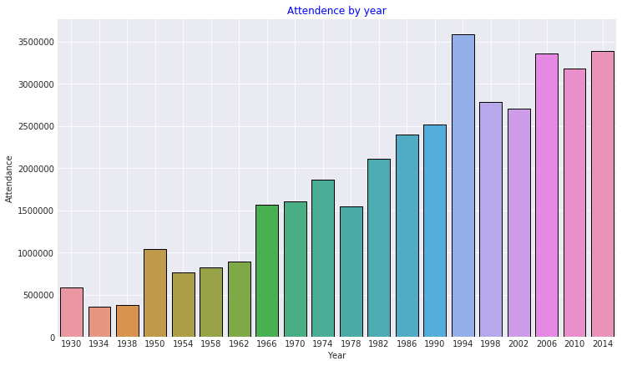

2- Average attendance by year

* A total of 3.43 million people watched the 64 games of the 2014 FIFA World Cup in Brazil live in the stadium. This meant that the average attendance per game was 53,758 , the highest average since the 1994 World Cup in the United States where average attendance is 68,991 per game.

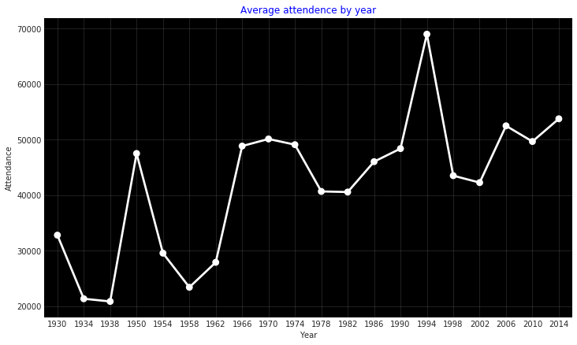

# 3- Total goals scored by year

* Highest number of goals have been secured in 1998 and 2014.

# 

4- Total matches played and qualified teams by year

* In the tournaments between 1934 and 1978, 16 teams competed in each tournament, except in 1938, when Austria was absorbed into Germany after qualifying, leaving the tournament with 15 teams, and in 1950, when India, Scotland, and Turkey withdrew, leaving the tournament with 13 teams
* The tournament was expanded to 24 teams in 1982, and then to 32 in 1998,also allowing more teams from Africa, Asia and North America to take part.

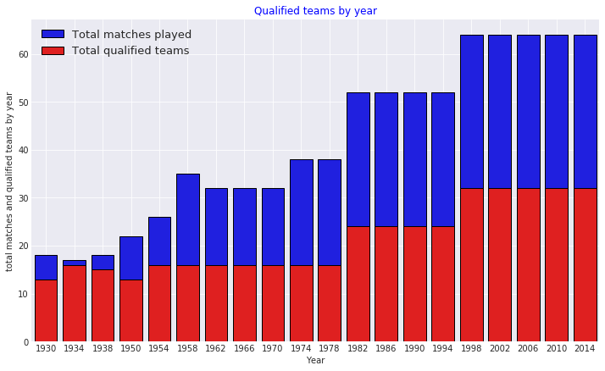

# 5- Matches with highest number of attendances

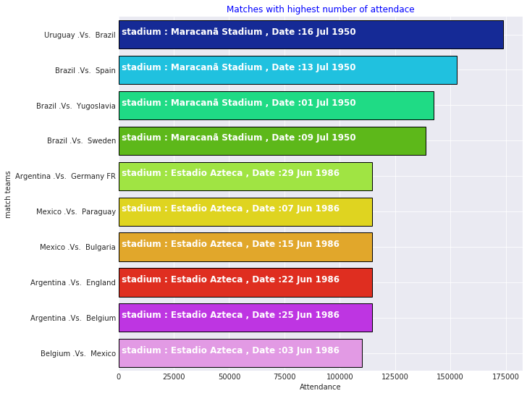

6- Teams with the most world cup final victories

* The 20 World Cup tournaments have been won by eight national teams. Brazil have won five times, and they are the only team to have played in every tournament. The other World Cup winners are Germany and Italy, with four titles each; Argentina and inaugural winner Uruguay, with two titles each; and England, France, and Spain, with one title each.
* Brazil, German and Italy have been great in world-cups.
* Where as Argentina never won again after 1986.

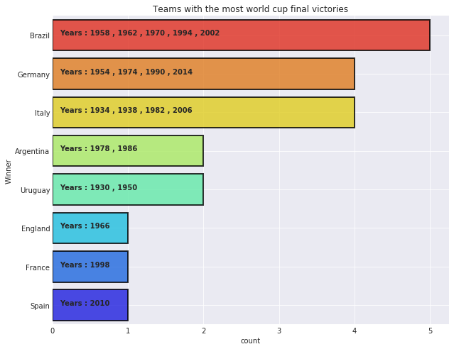

# 7-Teams with the most tournament participations

* Brazil has participated in the world cup the most *20 times*
* Italy and Germany have participated 18 times.
* Whereas Netherland, USA, Switzerland and Russia have participated only ten times that is by far the lowest.

# 

# 8- Home and away goals by year

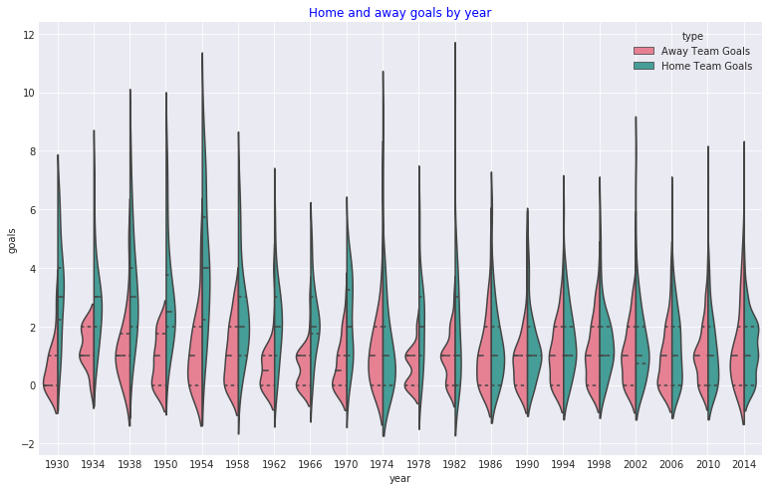

# 9- Match outcomes by home and away teams

# 

# 10-Teams with highest fifa world cup goals

# 

# 11- Highest total goals scored during a match

# 

Summary

This report provides a great insight of FIFA world-cup from 1930 to 2014, Not only does it tell about the teams winning it but also provides information about number f goals that have been secured so far and also the number of matches people attended each year. Every football fan loves information like this.